Grant Proposal Introduction
This document provides information about the project: Rotary Endowed Scholarship at the WSU College of Medicine. It was written to provide information typically required in local Rotary Club or Foundation grant proposals.

Project Overview

Organization Mission and Population Served
The Elson S. Floyd College of Medicine was created to fill critical health care gaps across Washington. It attracts talented students from or with significant ties to Washington – both rural and urban – to train within their communities, increasing the likelihood they will remain there to practice medicine. Current demographics are attached to this document.

Organization Details
Name and address: WSU Foundation, PO Box 641925, Pullman, WA 99164
501(c)(3) charitable organization EIN: 91-1075542 established 1979
Senior Development Director: Libby Manthei (920) 418-4626 elizabeth.manthei@wsu.edu
Organization’s budget and sources of revenue: see foundation.wsu.edu/about

Project Vision and Area of Focus
The Rotary Scholarship helps financially enable medical students to follow their passion for rural health care. | 

Project Mission
Bellevue Sunrise Rotary has established the Rotary Scholarship with the Washington State University (WSU) Foundation. The Elson S. Floyd College of Medicine was established to help reduce the shortage of physicians in vast areas of the state. The “Service Above Self” mission reflects not only the mission of the Rotary Districts across the world but reflects the mission and vision the Elson S. Floyd College of Medicine has for the State of Washington.

Project Sponsor
Name and address: Bellevue Sunrise Rotary Foundation, PO Box PO Box 52814, Bellevue, WA 98015
Contact person: Chris Carlson 425-260-0294 carlson@bellevuesunriserotary.org

Project Details
Name: Rotary Scholarship at the WSU College of Medicine
Rotary Area of Focus: Disease Prevention and Treatment
Statement of Need: Vast areas of Washington are currently underserved for medical care. The Rotary Scholarship helps financially enable medical students to follow their passion for rural health care. As a relatively new medical school, few scholarships are available to help offset college expenses. Healthcare providers serving rural communities may not be sufficiently remunerative to service college debt.

Project Goal
The goal is to offer one 4-year scholarship in the College of Medicine in 2021, then three more 4-year scholarships in subsequent years as funding permits, for a total of four scholarships. The current $100,000+ endowment provides roughly $4000 per year to fund four $1000 scholarships annually. One 4-year scholarship was awarded in 2021 and a second in 2022.

Project Description
Fundraising began in January 2021, with funds solicited from Rotary Clubs across Washington. Grants from Rotary clubs can be sent directly to the WSU Foundation to be deposited in the Rotary Scholarship Fund. Clubs and individuals can donate online to the Bellevue Sunrise Rotary Foundation which are periodically forwarded to the WSU Foundation. The WSU Foundation acknowledges donation checks they receive. Bellevue Sunrise Rotary acknowledges online donations.
For more information see https://www.bellevuesunriserotary.org/rotary-scholarship/ and the 2023 WSU College of Medicine Annual Report

How is Project Success Measured?
Goals:
- Raise $100,000 - achieved February 2025
- Award 4 four-year scholarships every year. Two have been awarded as of December 2024.

How is the Project Sustained?
A WSU Foundation Scholarship Endowment is being used. Donations are added to the endowment periodically as funds are collected. The endowment produces income annually which is provided to scholarship recipients. For example, a $100,000 endowment provides roughly $4000 per year which funds four $1000 scholarships annually. Management of the endowed funds and selection of the scholarship recipient is the responsibility of the WSU Foundation. The program sponsor has a deep relationship with and is the prime representative of Rotary to the WSU Foundation.

What are the Long-Term Community Benefits of this Project?
Improved access to medical care in the underserved areas of Washington is the expected benefit. The impact of the College of Medicine is already being felt as many of the inaugural class have completed their residencies and are beginning to practice. Over 100 graduates are in their Residency which lasts for 3 to 5 years. The College of Medicine tracks the progress of all graduates, so there will be metrics as they begin to appear in rural Washington communities.

Project Income
$100,000 has been raised between 2021 and January 2025.

Project Expenses
Individual donations’ credit card fees (unless paid by donor)
WSU Foundation operations fee (approximately 5% of donations)

Communication to Donors
The project is being promoted, when possible, through District 5020, 5030, 5040, 5060 and 5100 Newsletters. Similar content is provided in periodic emails sent to a list of more than 500 individual Rotarians. The ideal is to reach the approximately 9000 Rotarians in Washington.

Public Recognition of this Rotary Project

The WSU Foundation will publicly recognize the Rotary Scholarship through the WSU College of Medicine and the WSU Foundation. In previous years, the Elson S Floyd College of Medicine has been recognized in 129 newspaper and media stories ranging from the Seattle Times, AARP Real Possibilities, Everett Herald, The Columbian NPR, AP, Spokesman Review and many others.

The College of Medicine may recognize the Rotary Scholarship in several ways:

Featured newspaper stories throughout the state of Washington

College of Medicine Social Media pages: Facebook, Instagram and Twitter

College of Medicine Annual Report to all donors

Direct email communication to WSU Donors and friends

Grant Proposal
A donation of $1000 is suggested for Rotary Clubs of 50 members. Donations across multiple project years are welcome.

Donation by Check
To: Bellevue Sunrise Rotary Foundation
Note: GF007001 – Rotary Scholarship
Mail to: Bellevue Sunrise Rotary
PO Box 52814
Bellevue, WA 98015

Follow-up Communication
Upon your decision, we would appreciate status sent to carlson@bellevuesunriserotary.org . To subscribe to our periodic status email, please provide a list of names and email addresses. Subscriptions can be cancelled at any time using a link found at the bottom of a broadcast email.
Thank you for your consideration. Yours in Rotary,
Chris Carlson, Advocate
Rotary Scholarship at WSUMED
carlson@bellevuesunriserotary.org

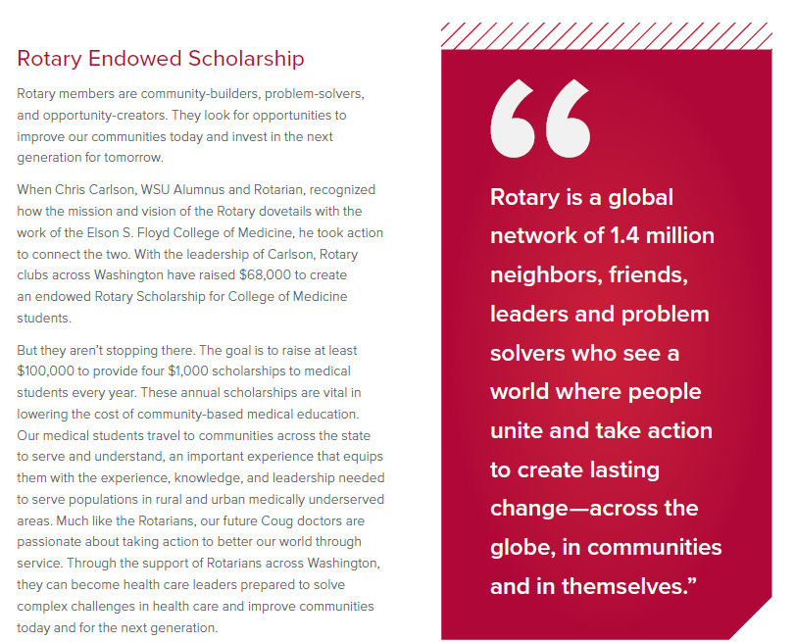
From Elson S. Floyd College of Medicine Annual Report 2023
www.MEDICINE.WSU.EDU

